Name: |  | Date:
Directions
Using your senses, describe how ______________ is to you.
____________ Sounds like… 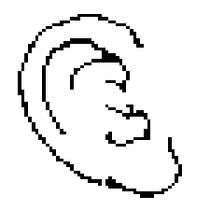
____________ Looks like… 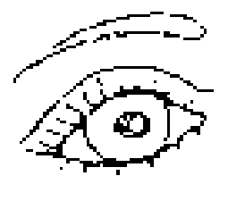
____________ Smells like… 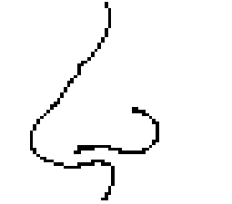
____________ Tastes like… 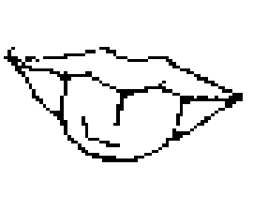
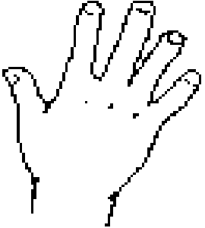

____________ Feels like…

